* React :
* A Javascrit library for building user interfaces.

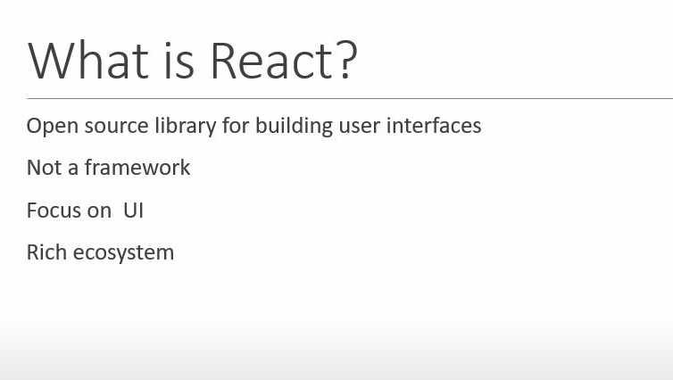



* Principles of react :
* Declarative
  + You tell react what u want your page to look like.
  + (What html it should render), and react will figure out
  + How to create and render html in the most optimal way
  + This improve predictability and is easier to debug.
* Component Based
  + Build individual components(functions) that create part of ur ui.
  + Logic is written in javascript or typescript.
  + Re use these components anywhere throughout ur app.
  + Allow you to break down complex apps into easy to create/use components.
* Learn Once, Write anywhere
  + React also work for mobile apps, on the server, and that can be added to existing tech stack
* Features of React :
* Uses Jsx : look like html code
* Virtual DOM improving performance
* One-way data flow
* Strong community
* Pre-requisites for react
* Html, Css, Javascript.
* 